**DAILY ONLINE ACTIVITIES SUMMARY**

|  |  |  |  |  |  |  |  |
| --- | --- | --- | --- | --- | --- | --- | --- |
| **Date:** | **20/05/20** | | | | **Name:** | **Namratha C** | |
| **Sem & Sec** | **8th sem, A sec** | | | | **USN:** | **4AL16CS056** | |
| **Online Test Summary** | | | | | | | |
| **Subject** | | **IoT** | | | | | |
| **Max. Marks** | | **30** | | **Score** | | **27** | |
| **Certification Course Summary** | | | | | | | |
| **Course** | **Introduction to Ethical Hacking** | | | | | | |
| **Certificate Provider** | | | **Great Learning** | **Duration** | | | **254 mins** |
| **Coding Challenges** | | | | | | | |
| **Problem Statement: 1) Generating Armstrong numbers using python 2) To reverse linked list in groups 3) Python prog to exchange the Values of Two Numbers using ^ operator** | | | | | | | |
| **Status: Completed** | | | | | | | |
| **Uploaded the report in Github** | | | | **Yes** | | | |
| **If yes Repository name** | | | | **CODES (Namrathasonu)** | | | |
| **Uploaded the report in slack** | | | | **Yes** | | | |

Online Test Details:



The test was on the subject Internet of Things on Module 1 and Module 2.

Certification Course Details:

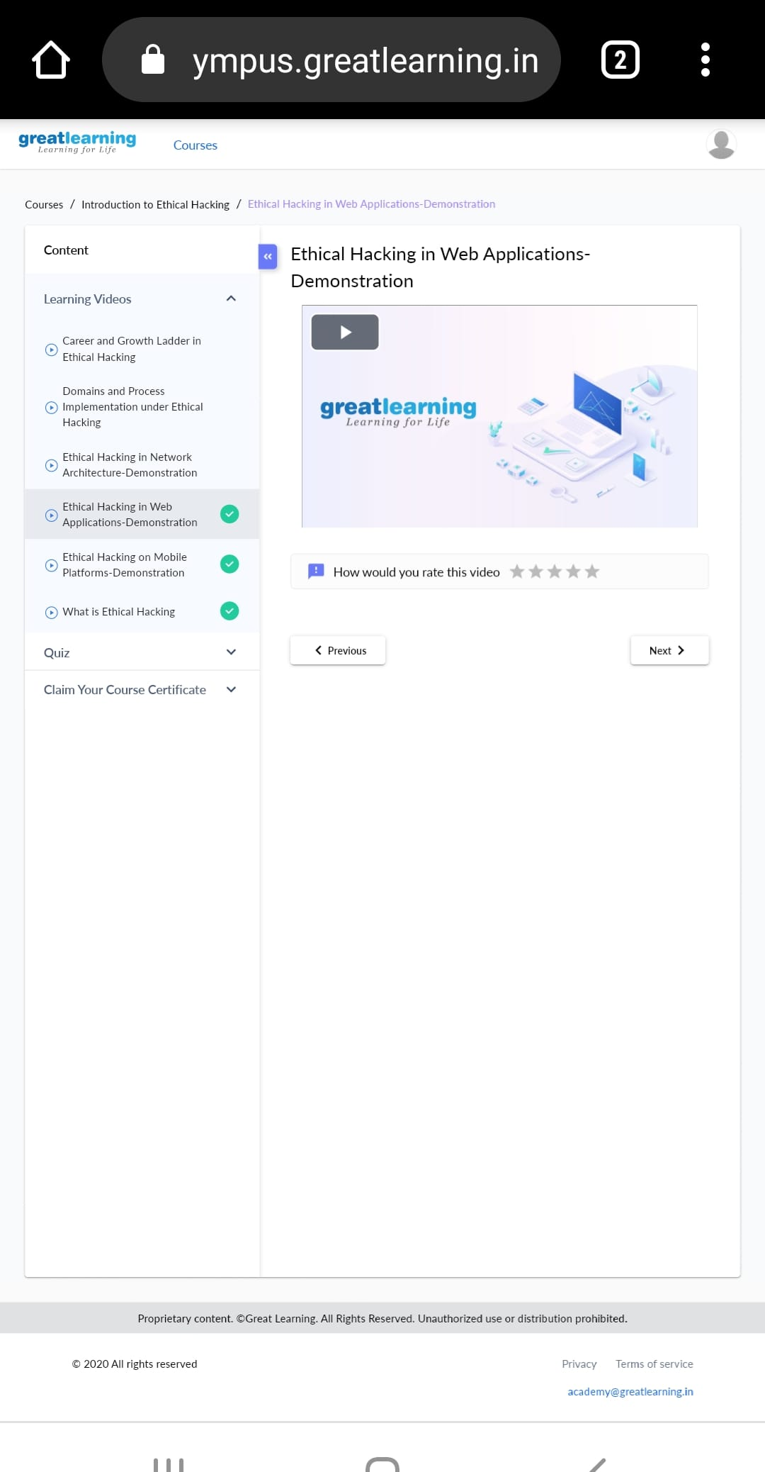

This topic is on the ethical hacking in Web Applications. Web hacking refers to exploitation of applications via HTTP which can be done by manipulating the application via its graphical web interface, tampering the Uniform Resource Identifier (URI) .

Coding Challenges Details:

1) Generating Armstrong numbers using Python programming language.

num = int(input("Enter a number: "))

sum = 0

temp = num

while temp > 0:

digit = temp % 10

sum += digit ** 3

temp //= 10

if num == sum:

print(num,"is an Armstrong number")

else:

print(num,"is not an Armstrong number")

2) Write a C Program to Reverse a Linked List in groups of given size.

Test Case 1:

If a linked listis: 1 → 2 → 3 → 4 → 5 → 6 → 7 → 8

The value of size k is 2

Then the linked list looks like: 2 → 1 → 4 → 3 → 6 → 5 → 8 → 7

Test Case 2:

If a linked listis: 1 → 2 → 3 → 4 → 5 → 6 → 7 → 8

The value of size k is 3

Then the linked list looks like: 3 → 2 → 1 → 6 → 5 → 4 → 8 → 7

struct Node

{

int data;

struct Node* next;

};

pointer to the new head node. /

struct Node reverse (struct Node head, int k)

{

struct Node current = head;

struct Node next = NULL;

struct Node prev = NULL;

int count = 0;

while (current != NULL && count < k) { next = current->next; current->next = prev; prev = current; current = next; count++; } if (next != NULL) head->next = reverse(next, k); return prev;

}

void push(struct Node** head_ref, int new_data)

{

struct Node* new_node =

(struct Node*) malloc(sizeof(struct Node));

new_node->data = new_data; new_node->next = (*head_ref); (*head_ref) = new_node;

}

void printList(struct Node *node)

{

while (node != NULL)

{

printf("%d ", node->data);

node = node->next;

}

}

int main(void)

{

struct Node* head = NULL;

push(&head, 8);

push(&head, 7);

push(&head, 6);

push(&head, 5);

push(&head, 4);

push(&head, 3);

push(&head, 2);

push(&head, 1);

printf("\nGiven linked list \n"); printList(head); head = reverse(head, 2); printf("\nReversed Linked list \n"); printList(head); return(0);

}

3) Python program Exchange the Values of Two Numbers using ^ operator

x=10 y=18 x = x ^ y; y = x ^ y; x = x ^ y; print ("After Swapping: x = ", x, " y =", y)